Course Report
2-week customized course on
“Use of GIS for Ground Water Studies”
(13th Dec – 24th Dec 2021)

National Hydrology Project (NHP) is being taken up by the Ministry of Jal Shakti, Department of Water Resources, RD & GR, Govt. of India, and the mission objective is to aid in effective water resources planning, development and management. This project is intended for setting up of a system for timely and reliable water resources measurement, storage, monitoring and management. It will also facilitate to provide tools/systems for informed decision making through Decision Support Systems (DSS) for water resources management, flood management, reservoir operations, drought management, etc. NHP also takes care of capacity building of the relevant State and Central government organizations in water resources management through the use of Information Systems and adoption of State-of-the-art technologies like Remote Sensing & GIS.
National Remote Sensing Centre (NRSC) has taken up the task to support NHP based on the request from Ministry of Jal Shakti, Department of Water Resources, River Development & Ganga Rejuvenation (MoJS, Dept. of WR, RD&GR) through organizing capacity building training programs comprising of Remote Sensing & GIS technologies and customized applications on water resources. These programs are aimed at capacity building of all the stake holders in understanding and effective utilization of space technology in the field of water resources. To this effect, two customized training programs per year of one week duration on the fundamentals aspects of RS & GIS and two customized programs per year of two weeks duration on the applications of RS & GIS in water resources are planned.
Andhra Pradesh State Ground Water and Water Audit (APSGW&WA) Department requested NRSC for training of their 24 officers on GIS tools and hands exercises particularly in ground water domain, data analysis, spatial analysis, etc.
In this regard, a two-week customised training programme on ‘Use of GIS for Ground Water Studies’ was conducted at National Remote Sensing Centre by Water Resources Group in association with Training & Education Group and Geosciences Group for officers of Andhra Pradesh State Ground Water and Water Audit Department under National Hydrology Project during 13-Dec-2021 to 24-Dec-2021. The details of which are described below.
The training programme was inaugurated on 13-Dec-2021 by Dr.Raj Kumar, Director, NRSC and co-chaired by Dr.M.V. Ravi Kumar, Deputy Director, Management Systems Area. Shri. P.V. Raju Group Director (WRG) welcomed all the participants and briefed about the training programme followed by remarks of co-chair and chair. A total of 24 officials participated in this course from Andhra Pradesh State Ground Water and Water Audit Department (refer Annexure-1).
The course is designed in such a way that it covers the overall concepts of GIS and its utility in Ground Water Exploration and management, starting from the fundamentals of Remote Sensing and GIS till the application of GIS technologies in Ground Water studies (refer Annexure-2). During the first day, the participants were introduced to remote sensing, image interpretation and classification techniques and hands-on exercises on image interpretation techniques in the afternoon sessions. Second day, topics on GIS were covered which includes introduction to GIS, Spatial data analysis techniques along with hands on exercises in afternoon sessions. On third day the topics covered include spatial interpolation techniques using GIS along with hands on exercises.
Fourth day, topics covered are basics of hydrogeology, overview of groundwater mapping and management using geo-spatial techniques, principles of Ground Water Prospects (GWP) mapping and case studies in hard rock terrain and hands on exercise on groundwater prospect map preparation in hard rock terrains. During fifth day the participants were introduced to ground water prospects mapping and case studies in alluvial areas & coastal areas and hands on exercise on groundwater prospects mapping in coastal and alluvial terrain. A guest lecture on ‘Ground water Recharge in Hard rock Terrain’ was special arrangement to the trainee participants on fifth day.
Sixth day the participants were taught geo-spatial techniques for site suitability analysis of artificial groundwater recharge with hands on exercise during afternoon sessions. Seventh day the topics covered include groundwater quality mapping techniques & case studies, 3D aquifer characteristics on groundwater regime and hand on exercise on groundwater quality mapping during afternoon sessions. A guest lecture on ‘Satellite based ground water studies in hard rock terrain, importance of fractures and lineaments’ was special arrangement to the trainee participants on seventh day. Eighth day topics covered include present and future applications on groundwater development, large scale groundwater prospects mapping and hands on exercise on large scale groundwater prospects mapping. In addition a guest lecture on ‘Ground water feature identification for source finding and sustainability’ was also arranged. Ninth day, a Ground truth field visit was organized to Pillapalli village and Bata singaram locations surrounding Hyderabad. The trainee officers were appraised about demarcation of dikes, lineaments, water bodies, percolation ponds and fracture valleys using satellite data. The tenth day topics covered include satellite data products & dissemination and the participants were shown demos on Bhuvan (covering topics like Bhujal, Thematic Services - Lineament 50K, LU/LC, WBIS, etc) and India-WRIS. A lecture on water resource information portals was also arranged.
Feedback was obtained from all the participants on the overall training programme and on each topic-wise. The trainees expressed happiness for including more hands on practical exercises in this training programme. The ratings are very good and the overall course feedback is 4.38 out of 5.
The concluding session was held on 24-Dec-2021 chaired by Dr. V.V. Rao, Deputy Director, RSA Area and co-chaired by Dr. Gnanasundar, Senior Joint Commissioner, NHP, New Delhi and Dr.N.Srinivasulu, Deputy Director, APSGW&WA department. The Training Programme was concluded with distribution of Certificates by Dr. V.V. Rao, Deputy Director, RSA Area & Shri.P.V.Raju Group Director (WRG) and feedback from the Trainee Officers.

Few Photographs of the Training Programme Inaugural Session
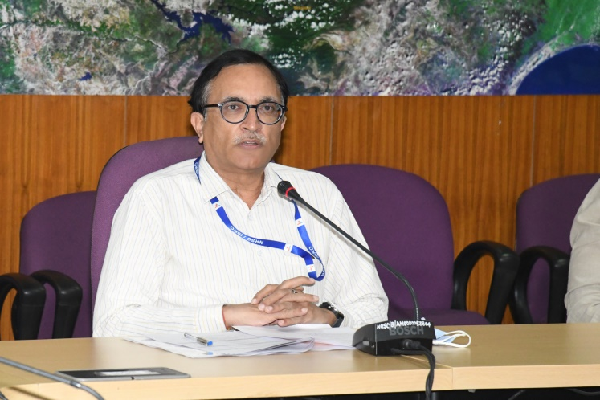 | 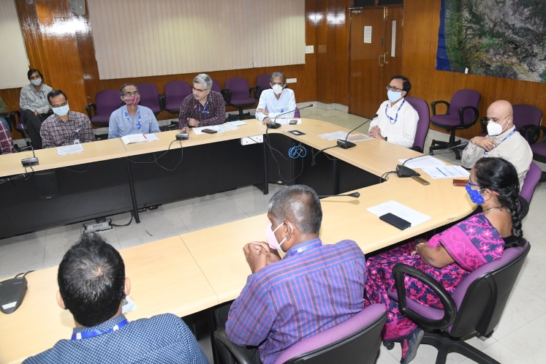
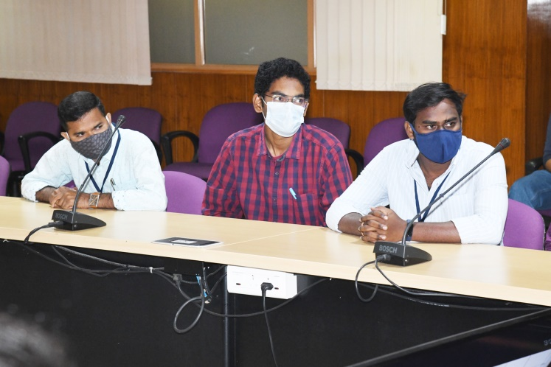 | 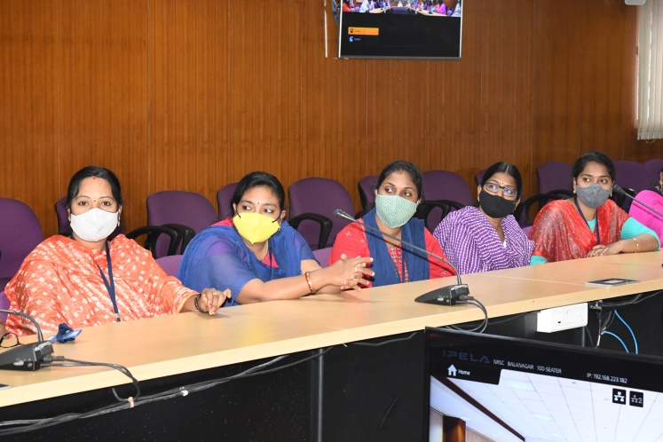
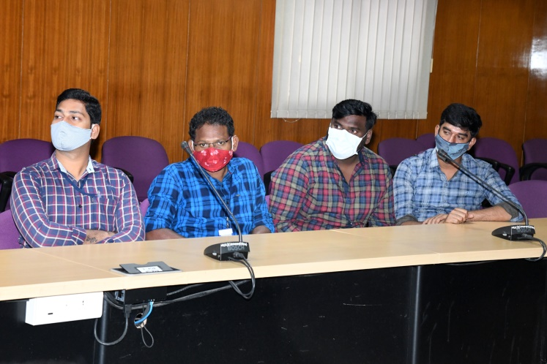 | 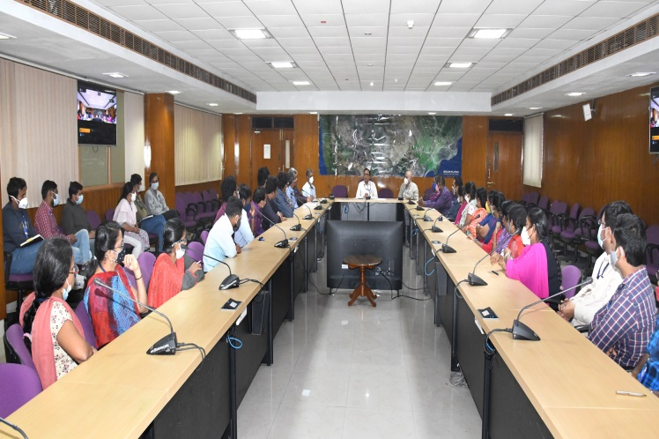

Few Photographs during hands-on exercise of the Training Programme
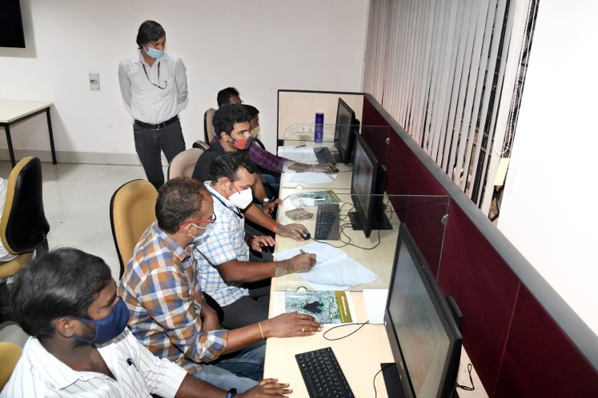 | 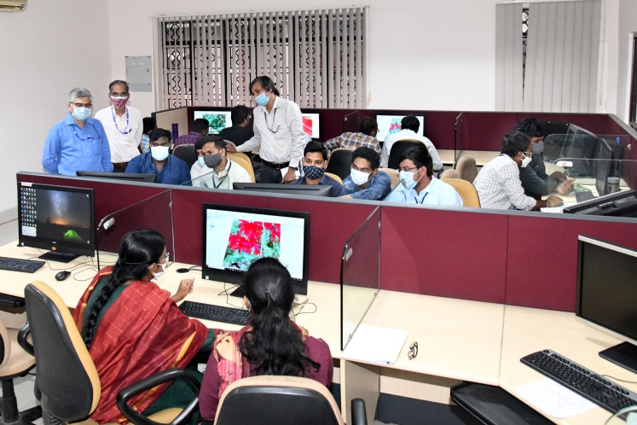
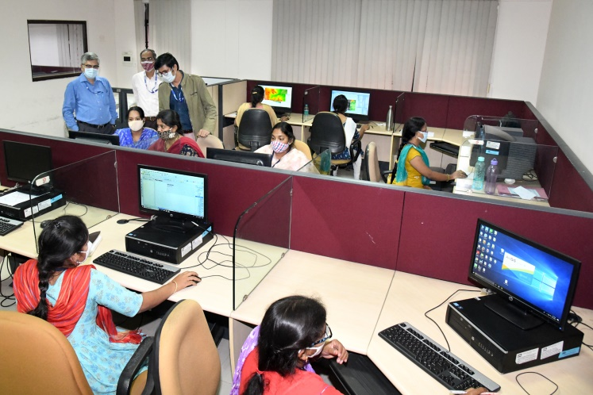 | 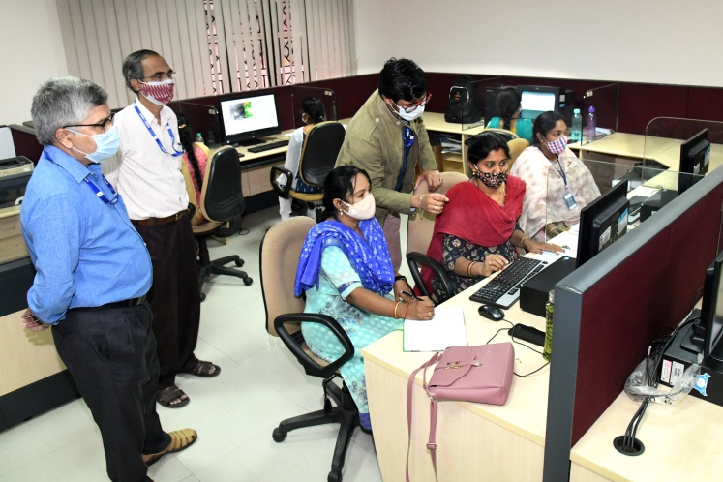
Trainee officers and faculty with Director, NRSC
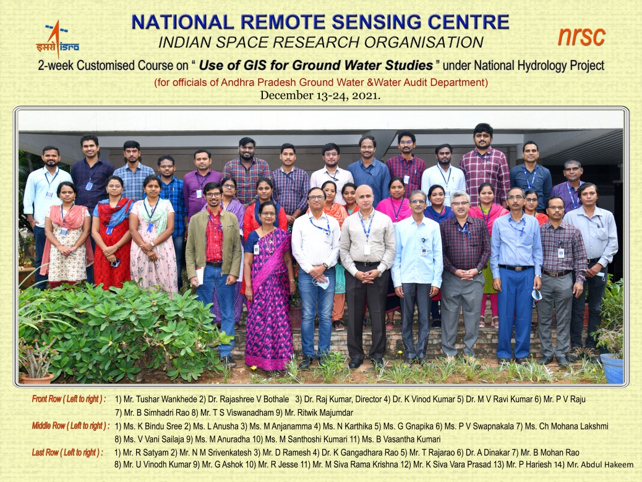

Few Photographs during Ground Truth Field Visit to surroundings of Hyderabad

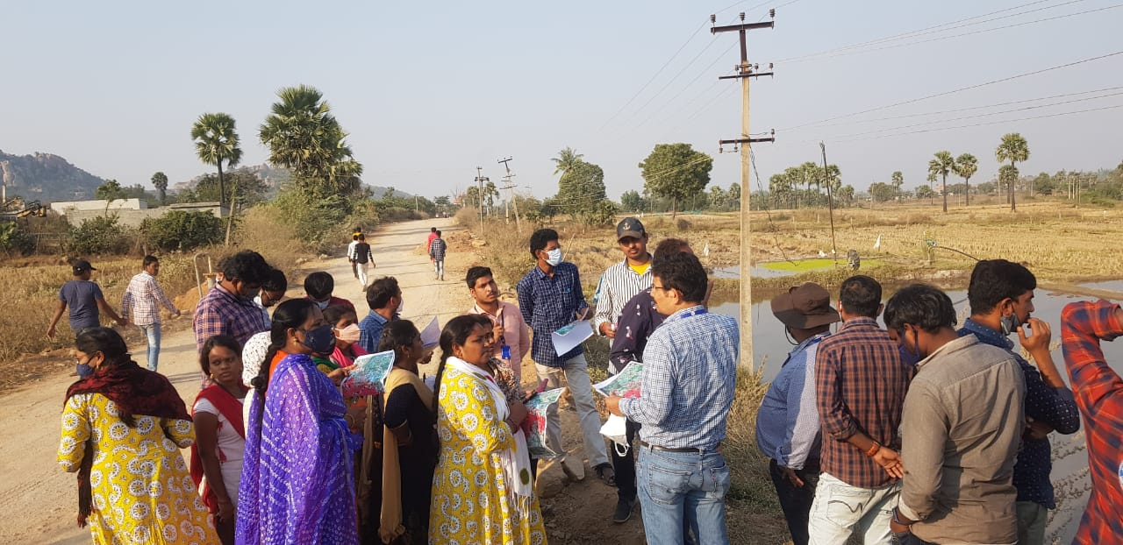
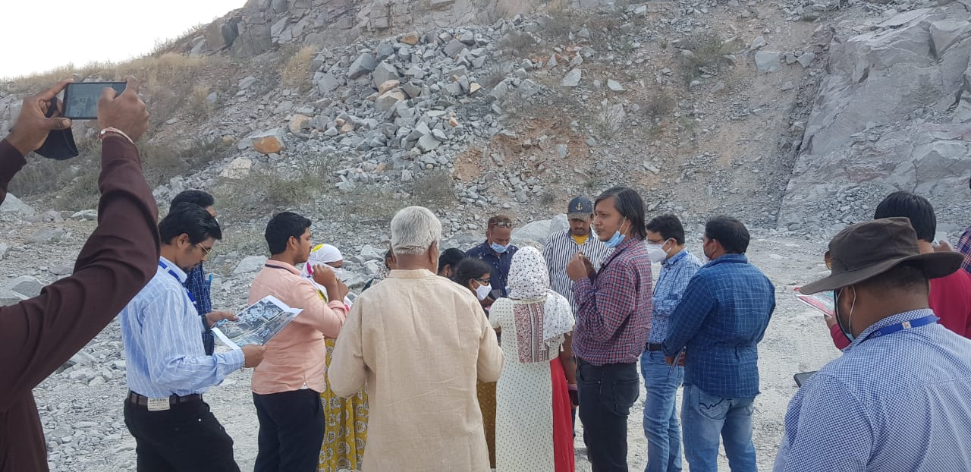
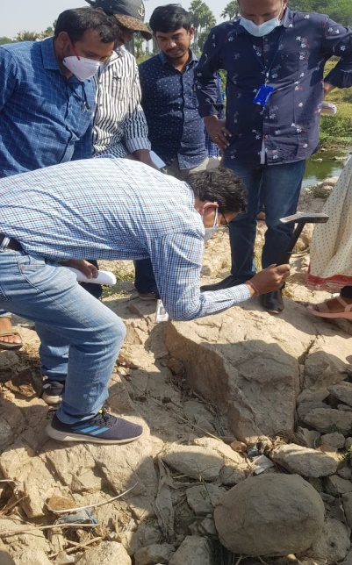 | 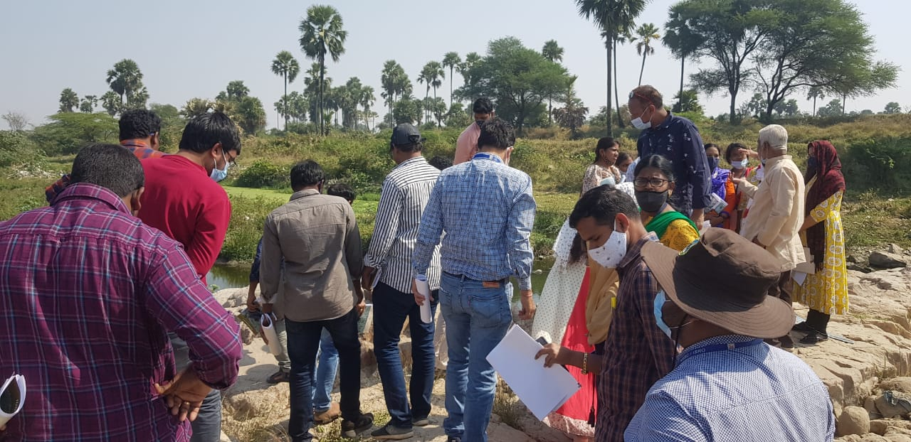

Few Photographs of the Training Programme Concluding Session
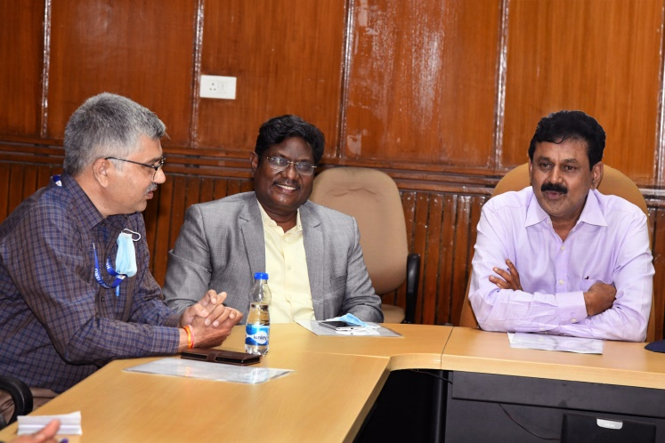 | 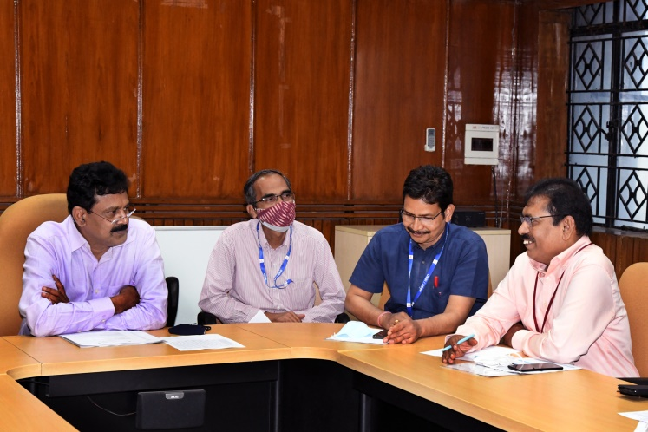
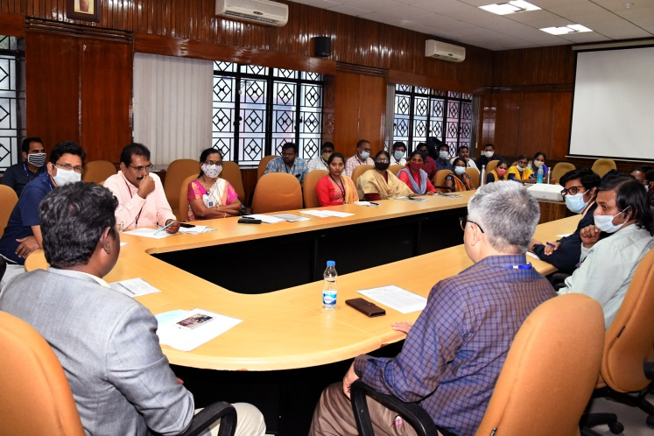 | 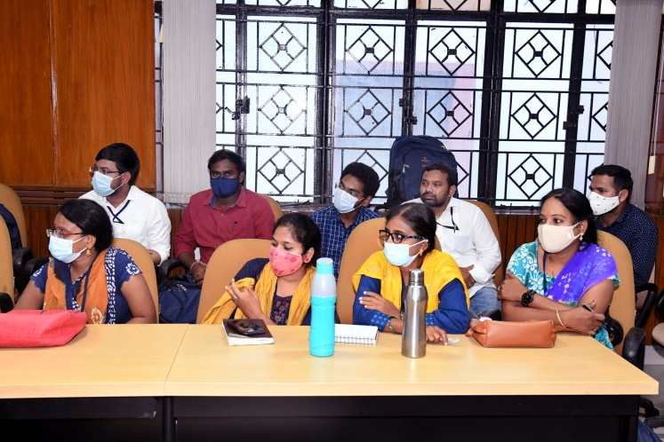
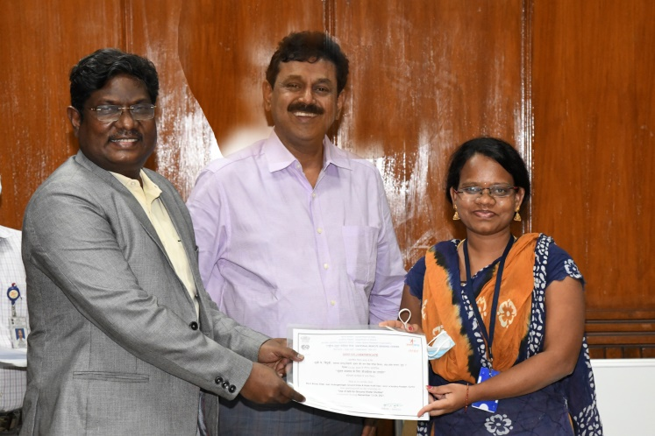 | 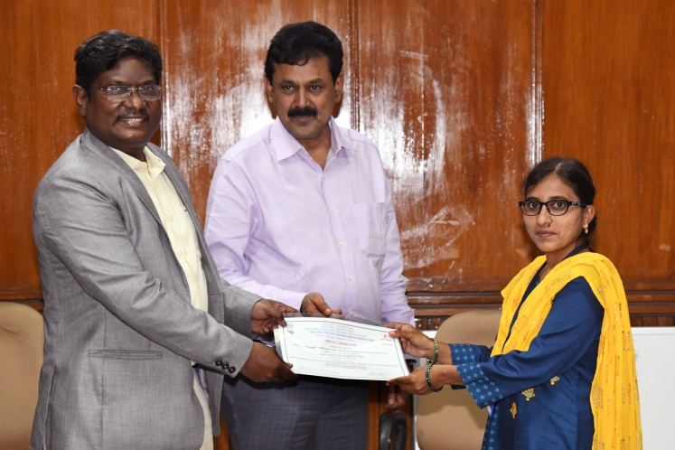
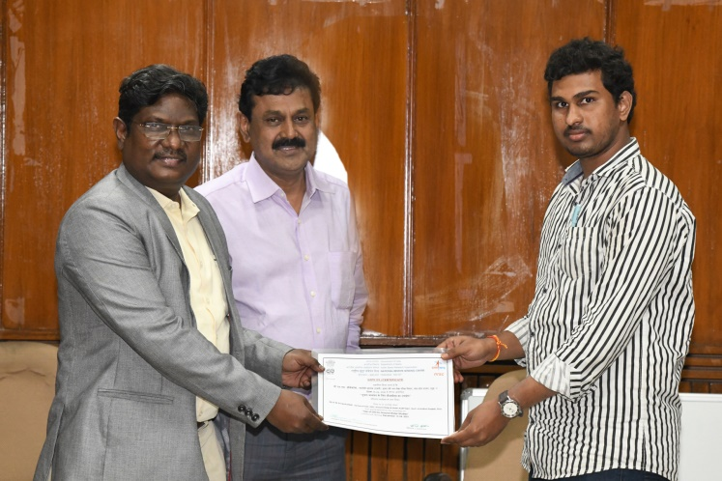 | 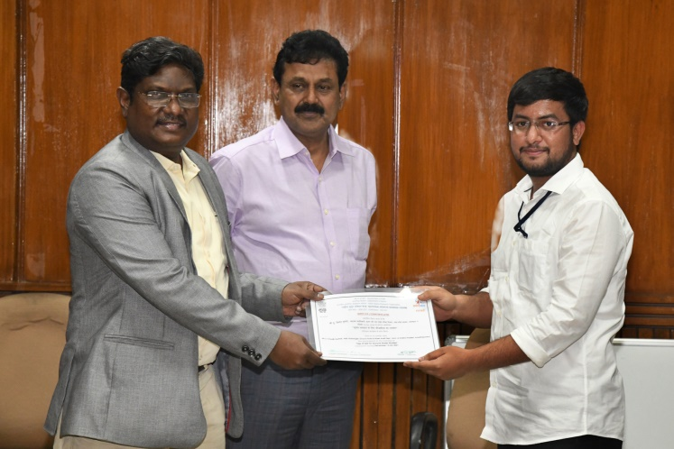
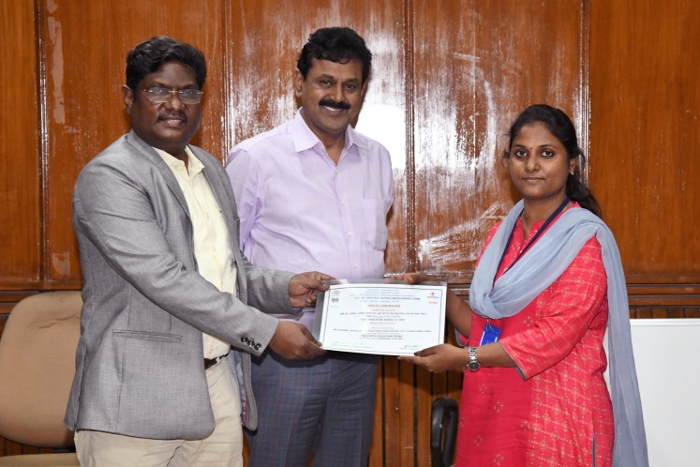 | 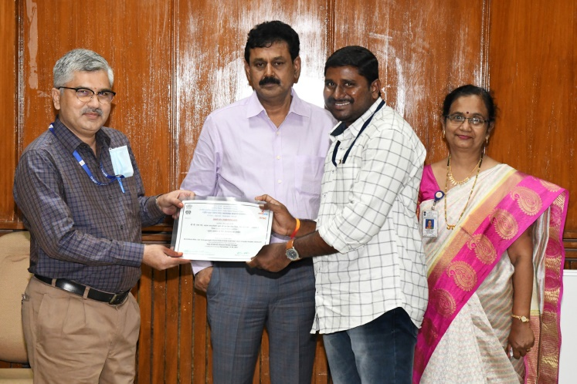
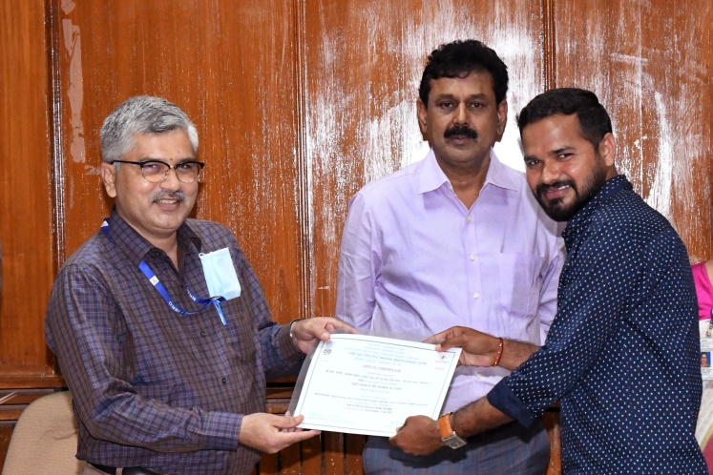 | 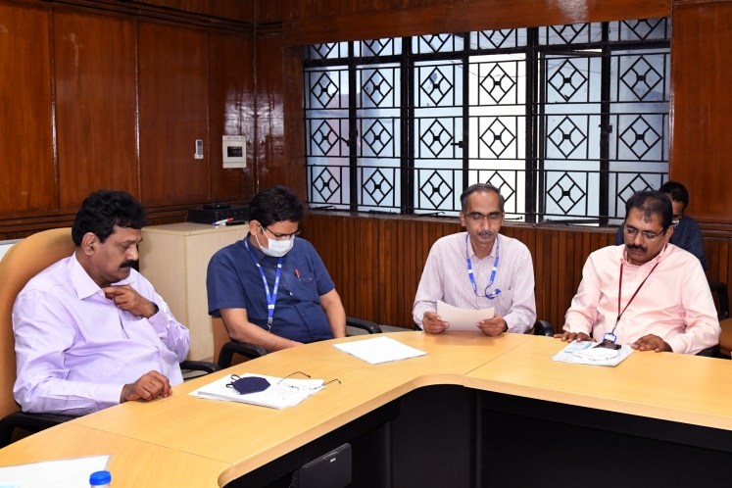

Annexure 1
List of Officers attended the Training Programme
Sl. No. | Name | Designation | Working Office | City
1 | K Bindu Sree | Assistant Hydrogeologist | DD,GW&WAD | Guntur
2 | K Siva Vara Prasad | Assistant Engineer (C ) | DD,GW&WAD | Guntur
3 | L Anusha | Technical Assistant (Hg) | DD,GW&WAD | Ongole
4 | B Vasantha Kumari | Technical Assistant (Gp) | GW&WAD | Ongole
5 | N M Srivenkatesh | Technical Assistant (Hg) | DD, GW&WAD | Eluru
6 | V Vani Sailaja | Assistant Hydrogeologist | DD, GW&WAD | Eluru
7 | U Vinod Kumar | Assistant Hydrologist | DD, GW&WAD | Ananthapuram
8 | B Mohan Rao | Assistant Hydrogeologist | AD, GW&WAD (CUFU) | Ananthapuram
9 | G Gnapika | Technical Assistant (H) | GW&WAD | Chittoor
10 | N Karthika | Technical Assistant (Gp) | DD, GW&WAD | Chittoor
11 | P V Swapnakala | Assistant Hydrologist | DD, GW&WAD | Kadapa
12 | Ch Mohana Lakshmi | Technical Assistant (Gp) | DD, GW&WAD | Kadapa
13 | C.Sivaswaminadhan | Technical Assistant (Hg) | DD, GW&WAD | Kurnool
14 | R Jesse | Assistant Engineer (C ) | DD, GW&WAD | Kurnool
15 | K Gangadhara Rao | Assistant Director | DD, GW&WAD | Dowliswaram
16 | G Ashok | Assistant Hydrologist | DD, GW&WAD | Dowliswaram
17 | G Rama Rao | Assistant Hydrogeologist | GW&WAD | Srikakulam
18 | R Satyam | Technical Assistant (Hg) | DD, GW&WAD | Srikakulam
19 | M Santhoshi Kumari | Technical Assistant (Gp) | DD, GW&WAD | Vizianagaram
20 | M Anjanamma | Assistant Hydrogeologist | DD, GW&WAD | Nandyala
21 | M Siva Rama Krishna | Assistant Hydrologist | DD, GW&WAD | Vijayawada
22 | A Dinakar | Assistant Hydrogeologist | DD, GW&WAD | Nellore
23 | T Rajarao | Assistant Geophysicist | DD. GW&WAD | Nellore
24 | D Ramesh | Technical Assistant (Gp) | DD, GW&WAD | Visakhapatnam

Annexure 2

PROGRAMME SCHEDULE
Date&Time | Title | Faculty
Day-1 : 13December, 2021 (Monday)
09:15-10:00 hrs. | Registration | TEG
10:00-10:30 hrs. | Inauguration Session | WRG, GSG and TEG
10:30-10:45 hrs. | Tea Break
10:45-12:00 hrs. | Introduction to Remote Sensing | Mr. T S Viswanadham, TEOG
12:00-13:15 hrs. | Image Interpretation& Classification Techniques | Mr. P Hariesh, TEOG
13:15-14:15 hrs. | Lunch Break
14:15-15:30 hrs. | Hands-on Exercise on Image Interpretation | Mr. P Hariesh, TEOG
15:30-15:45 hrs. | Tea Break
15:45-17:15 hrs. | Hands-on Exercise on Image Interpretation | Mr. P Hariesh, TEOG
Day-2 : 14December, 2021(Tuesday)
09:15-10:30 hrs. | Introduction to GIS | Mr. P V S S N Gopala Krishna, Head, TPCD, TEOG
10:30-10:45 hrs. | Tea Break
10:45-11:45 hrs. | Spatial Data Analysis Techniques | Mr. T S Viswanadham, TEOG
11:45-13:15 hrs. | Hands-on Exercises in GIS (shape file creation, subset, dissolve, etc.) | Mr. T S Viswanadham, TEOG
13:15-14:15 hrs. | Lunch Break
14:15-15:30 hrs. | Hands-on Exercises in GIS (shape file creation, subset, dissolve, etc.) | Mr. T S Viswanadham, TEOG
15:30-15:45 hrs. | Tea Break
15:45-17:15 hrs. | Hands-on Exercises in GIS (shape file creation, subset, dissolve, etc.) | Mr. T S Viswanadham, TEOG
Day-3 : 15 December, 2021(Wednesday)
09:15-10:30 hrs. | Spatial Interpolation Techniques using GIS | Mr. T S Viswanadham, TEOG
10:30-10:45 hrs. | Tea Break
10:45-12:15 hrs. | Hands-on Exercise on GIS (querying, buffering, GIS operations, interpolation, etc.) | Mr. T S Viswanadham, TEOG
12:15-13:15 hrs. | Hands-on Exercise on GIS (querying, buffering, GIS operations, interpolation, etc.) | Mr. T S Viswanadham, TEOG
13:15-14:15 hrs. | Lunch Break
14:15-15:30 hrs. | Hands-on Exercise on GIS (querying, buffering, GIS operations, interpolation, etc.) | Mr. T S Viswanadham, TEOG
15:30-15:45 hrs. | Tea Break
15:45-17:15 hrs. | Hands-on Exercise on GIS (querying, buffering, GIS operations, interpolation, etc.) | Mr. T S Viswanadham, TEOG
Day-4 : 16 December, 2021(Thursday)
09:15-10:30hrs. | Basics of Hydrogeology | Dr. I C Das, Head HGD, GSG
10:30-10:45 hrs. | Tea Break
10:45-12:00 hrs. | Overview of Groundwater Mapping and Management using Geo-spatial Techniques | Dr. I C Das, Head HGD, GSG
12:00-13:15 hrs. | Principles of Groundwater Prospects (GWP) Mapping and Case Studies in Hard Rock Terrain | Dr. I C Das, Head HGD, GSG
13:15-14:15 hrs. | Lunch Break
14:15-15:30 hrs. | Hands-on Exercises on for Groundwater  Prospect map preparation in hard rock terrains  - Geological database (lineament, Lithology)access, download and ingestion from GSI’s ‘Bhukosh’ portal  - Interpretation of geomorphology, lineament, drainage etc using EO data  - Thematic layer/ database preparation  - Geo-spatial integration for preparation of groundwater Prospect maps | Mr. R Majumdar, HGD, GSG
15:30-15:45 hrs. | Tea Break
15:45-17:15 hrs. | Hands-on Exercises (contd.) | Mr. R Majumdar, HGD, GSG
Day-5 : 17 December, 2021(Friday)
09:15-10:30hrs. | Groundwater Prospects Mapping and Case Studies in Alluvial Areas |  | Dr. I C Das, Head HGD, GSG
10:30-10:45hrs. | Tea Break
10:45-12:00 hrs. | Groundwater Prospects Mapping and Case Studies in Coastal Areas |  | Dr. I C Das, Head HGD, GSG
12.00-13.15 hrs | Guest lecture: Ground water recharge in hard rock terrain |  | Dr. Ranga Rajan (Ex NGRI)
13:15-14:15 hrs. | Lunch Break
14:15-15:30hrs. | Hands-on Exercises on for Groundwater Prospects mapping in coastal and alluvial terrain  - EO based interpretation of hydro-geomorphic units and geo-spatial thematic layers preparation in coastal and alluvial terrain  - Groundwater Prospects mapping in coastal & alluvial terrain using Geo-spatial techniques |  | Mr. R Majumdar, HGD, GSG
15:30-15:45hrs. | Tea Break
15:45-17:15hrs. | Hands-on Exercises (contd.) |  | Mr. R Majumdar, HGD, GSG
Day-7 : 20 December, 2021(Monday)
09:15-10:30hrs. | Geo-spatial Techniques for Site Suitability Analysis of Artificial Groundwater Recharge | Mr. R Saha, HGD, GSG
10:30-10:45hrs. | Tea Break
10:45-13:15hrs. | Contd… | Mr. R Saha, HGD, GSG
13:15-14:15hrs. | Lunch Break
14:15-15:30hrs. | Hands-on Exercises on Site Suitability Zonation for Artificial Groundwater Recharge  - Selection and generation of hydrogeological thematic layers  - Normalized weight computation of thematic layers using AHP and MIF MCDA techniques  - Groundwater recharge zone delineation using weighted sum | Mr. R Saha, HGD, GSG
15:30-15:45hrs. | Tea Break
15:45-17:15hrs. | Contd.. | Mr. R Saha, HGD, GSG
Day-8 : 21 December, 2021(Tuesday)
09:15-10:30hrs. | Groundwater Quality (GWQ)Mapping Techniques and Case Studies (GWQ Trend Analysis) | Mr. R Majumdar, HGD, GSG
10:30-10:45hrs. | Tea Break
10:45-12:00hrs. | Guest Lecture: Satellite based ground water studies in hard rock terrain, importance of fractures and lineaments. | Mr.K. Seshadri (Ex NRSC)
12:00-13:15hrs. | 3D Aquifer Characteristics on Groundwater Regime | Mr. T Wankhede, HGD, GSG
13:15-14:15hrs. | Lunch Break
14:15-15:30hrs. | Hands-on Exercises on Groundwater Quality (GWQ) Mapping  - Accessing GWQ database from IMIS  - GWQ data segregation and filtering  - Geo-spatial data preparation of GWQ data  - Element wise GWQ layer preparation ( geo-spatial interpolation)  - Geo-spatial integration and preparation of GWQ database/maps  - Validation of GWQ maps | Mr. R Majumdar & Mr. T Wankhede, HGD, GSG
15:30-15:45hrs. | Tea Break
15:45-17:15hrs. | Hands-on Exercises (contd.) | Mr. R Majumdar, HGD, GSG
Day-9 : 22 December, 2021(Wednesday)
09:15-10:30hrs. | Present and Future Applications on Groundwater Development | Mr. R Saha, HGD, GSG
10:30-10:45hrs. | Tea Break
10:45-12:00hrs. | Large scale groundwater prospects mapping | Mr. R Saha, HGD, GSG
12:00-13:15hrs. | Guest lecture: Ground water feature identification for source finding and sustainability | Dr. P N Rao (Ex CGWB)
13:15-14:15hrs. | Lunch Break
14:15-15:30hrs. | Hands-on overview on large scale groundwater prospects mapping  - Hydrogeological database (lineament, Lithology) access, download and ingestion from GSI’s ‘Bhukosh’ portal in 1:50,000 scale and updating the same to 1:10,000 scale using satellite imagery and DEM  - Interpretation of geomorphology, lineament, drainage etc using EO data  - Thematic layer/ database preparation  - Geo-spatial integration of field data with different thematic layers for preparation of groundwater Prospect maps | Mr. R Saha, HGD, GSG
15:30-15:45hrs. | Tea Break
15:45-17:15hrs. | Hands-on Exercises (contd.) | Mr. R Saha, HGD, GSG
Day-10 : 23 December, 2021(Thursday)
09:15-1315 hrs. | Field visit around Hyderabad for groundwater mapping | HGD, GSG Team &  Dr. Murlidharan (Ex NGRI)
 | Tea Break
 | Field visit around Hyderabad for groundwater mapping
13:15-14:15hrs. | Lunch Break
14:15-17:15hrs. | Field visit around Hyderabad for groundwater mapping
 | Tea Break
 | Field visit around Hyderabad for groundwater mapping
Day-11 : 24December, 2021(Friday)
09:15-10:30hrs. | Satellite Data Products and Dissemination | Dr. S. Arunachalam, NDC
10:30-10:45hrs. | Tea Break
10:45-11:45hrs. | Water Resources Information Portals | Mr. Saksham Joshi, WRG
11:45-13:15hrs. | Demo on BHUVAN Web Services (Bhujal, Thematic Services - Lineament 50K, LU/LC, WBIS, etc) | Mr. J. Sai Rama Krishna, G&WGA
13:15-14:15hrs. | Lunch Break
14:15-15:30hrs. | Feedback & Discussion | HGD, GSG & TEOG
15:45-17:00hrs. | Concluding Session & High Tea | WRG and TEG
ASG: Agricultural Sciences Group | G&WGS: Geo-portal & Web GIS Services Group
NDC: NRSC Data Centre | TEG: Training & Education Group
GSG: Geosciences Group | WRG: Water Resources Group

***

